Generic Blank Game Design Document (GDD)



***‘Why did the chicken cross the road?*** – Isaia Pacheco

This page: Table of Contents and Team Member Listing

|  |  |
| --- | --- |
| Table of Contents  [1 Game Overview](https://n-xovwktmtjsnaxyc2mwes2xu7pohqedmdm6zjw5q-2lu-script.googleusercontent.com/userCodeAppPanel)  [2 High Concept](https://n-xovwktmtjsnaxyc2mwes2xu7pohqedmdm6zjw5q-2lu-script.googleusercontent.com/userCodeAppPanel)  [3 Unique Selling Points](https://n-xovwktmtjsnaxyc2mwes2xu7pohqedmdm6zjw5q-2lu-script.googleusercontent.com/userCodeAppPanel)  [4 Platform Minimum Requirements](https://n-xovwktmtjsnaxyc2mwes2xu7pohqedmdm6zjw5q-2lu-script.googleusercontent.com/userCodeAppPanel)  [5 Competitors / Similar Titles](https://n-xovwktmtjsnaxyc2mwes2xu7pohqedmdm6zjw5q-2lu-script.googleusercontent.com/userCodeAppPanel)  [6 Synopsis](https://n-xovwktmtjsnaxyc2mwes2xu7pohqedmdm6zjw5q-2lu-script.googleusercontent.com/userCodeAppPanel)  [7 Game Objectives](https://n-xovwktmtjsnaxyc2mwes2xu7pohqedmdm6zjw5q-2lu-script.googleusercontent.com/userCodeAppPanel)  [8 Game Rules](https://n-xovwktmtjsnaxyc2mwes2xu7pohqedmdm6zjw5q-2lu-script.googleusercontent.com/userCodeAppPanel)  [9 Game Structure](https://n-xovwktmtjsnaxyc2mwes2xu7pohqedmdm6zjw5q-2lu-script.googleusercontent.com/userCodeAppPanel)  [10 Game Play](https://n-xovwktmtjsnaxyc2mwes2xu7pohqedmdm6zjw5q-2lu-script.googleusercontent.com/userCodeAppPanel)  [10.1 Game Controls](https://n-xovwktmtjsnaxyc2mwes2xu7pohqedmdm6zjw5q-2lu-script.googleusercontent.com/userCodeAppPanel)  [10.2 Game Camera](https://n-xovwktmtjsnaxyc2mwes2xu7pohqedmdm6zjw5q-2lu-script.googleusercontent.com/userCodeAppPanel)  [10.2.1 HUD](https://n-xovwktmtjsnaxyc2mwes2xu7pohqedmdm6zjw5q-2lu-script.googleusercontent.com/userCodeAppPanel)  [10.2.2 Maps](https://n-xovwktmtjsnaxyc2mwes2xu7pohqedmdm6zjw5q-2lu-script.googleusercontent.com/userCodeAppPanel)  [11 Players](https://n-xovwktmtjsnaxyc2mwes2xu7pohqedmdm6zjw5q-2lu-script.googleusercontent.com/userCodeAppPanel)  [11.1 Characters](https://n-xovwktmtjsnaxyc2mwes2xu7pohqedmdm6zjw5q-2lu-script.googleusercontent.com/userCodeAppPanel)  [11.2 States](https://n-xovwktmtjsnaxyc2mwes2xu7pohqedmdm6zjw5q-2lu-script.googleusercontent.com/userCodeAppPanel)  [12 Player Line-up](https://n-xovwktmtjsnaxyc2mwes2xu7pohqedmdm6zjw5q-2lu-script.googleusercontent.com/userCodeAppPanel)  [13 NPC](https://n-xovwktmtjsnaxyc2mwes2xu7pohqedmdm6zjw5q-2lu-script.googleusercontent.com/userCodeAppPanel)  [13.1 Enemies](https://n-xovwktmtjsnaxyc2mwes2xu7pohqedmdm6zjw5q-2lu-script.googleusercontent.com/userCodeAppPanel)  [13.1.1 Enemy States](https://n-xovwktmtjsnaxyc2mwes2xu7pohqedmdm6zjw5q-2lu-script.googleusercontent.com/userCodeAppPanel)  [13.1.2 Enemy Spawn Points](https://n-xovwktmtjsnaxyc2mwes2xu7pohqedmdm6zjw5q-2lu-script.googleusercontent.com/userCodeAppPanel)  [14 Art](https://n-xovwktmtjsnaxyc2mwes2xu7pohqedmdm6zjw5q-2lu-script.googleusercontent.com/userCodeAppPanel)  [14.1 Setting](https://n-xovwktmtjsnaxyc2mwes2xu7pohqedmdm6zjw5q-2lu-script.googleusercontent.com/userCodeAppPanel)  [14.2 Level Design](https://n-xovwktmtjsnaxyc2mwes2xu7pohqedmdm6zjw5q-2lu-script.googleusercontent.com/userCodeAppPanel)  [14.3 Audio](https://n-xovwktmtjsnaxyc2mwes2xu7pohqedmdm6zjw5q-2lu-script.googleusercontent.com/userCodeAppPanel)  [15 Biography](https://n-xovwktmtjsnaxyc2mwes2xu7pohqedmdm6zjw5q-2lu-script.googleusercontent.com/userCodeAppPanel)  [15.1 Original](https://n-xovwktmtjsnaxyc2mwes2xu7pohqedmdm6zjw5q-2lu-script.googleusercontent.com/userCodeAppPanel) Content  [15.2](https://n-xovwktmtjsnaxyc2mwes2xu7pohqedmdm6zjw5q-2lu-script.googleusercontent.com/userCodeAppPanel) Borrowed Content | Game Development Team Members    PRODUCER  Isaia Pacheco    PRODUCTION MANAGER  Isaia Pacheco    PRODUCTION COORDINATOR  Isaia Pacheco  GAME DESIGNERS  Isaia Pacheco  SYSTEMS/IT COORDINATOR  Isaia Pacheco  PROGRAMMERS  Isaia Pacheco  TECHNICAL ARTISTS  Isaia Pacheco  AUDIO ENGINEERS  Isaia Pacheco  UX TESTERS  Isaia Pacheco |

|  |
| --- |
|  |

# 1 Game Overview

Title: Hurry Up!

Platform: PC Standalone

Genre: Genre of your game

Rating: Arcade

Target: Casual gamer (aging from 12 - 30)

Release date: November 2020

Publisher: Pacheco Gaming

Description: This game will take your adrenaline through the roof and hopefully not on the roof off a car! You will be tasked to cross a busy street filled with speeding cars. How daring are you to cross?

# 2 High Concept

Everyone knows the joke “why did the chicken cross the road?” and simplicity. Hurry Up! Will take an anti-humor and blend it with a classic.

# 3 Unique Selling Points

* Easy to play
* Popular soundtrack
* Top-down View

# 4 Platform Minimum Requirements

* PC x86 Standalone
* 16:9 Ratio
* Keyboard

# 5 Competitors / Similar Titles

* Frogger
* Crossy Road
* Grogger
* Flappy Bird

# 6 Synopsis

The user is a chicken trying to get to other side of the road. The user will dodge moving cars in hopes of getting its egg.

# 7 Game Objectives

The game objective is to cross the road 10 times in a row without dying.

# 8 Game Rules

* One life
* Do not get hit by a car
* Get to the other side of the road
* Get the egg

# 9 Game Structure

# 10 Game Play

## 10.1 Game Controls

* A or Left arrow key to go left
* D or Right arrow key to go right
* W or Up arrow key to go up
* S or Down arrow key to go down.

## 10.2 Game Camera

### 10.2.1 HUD

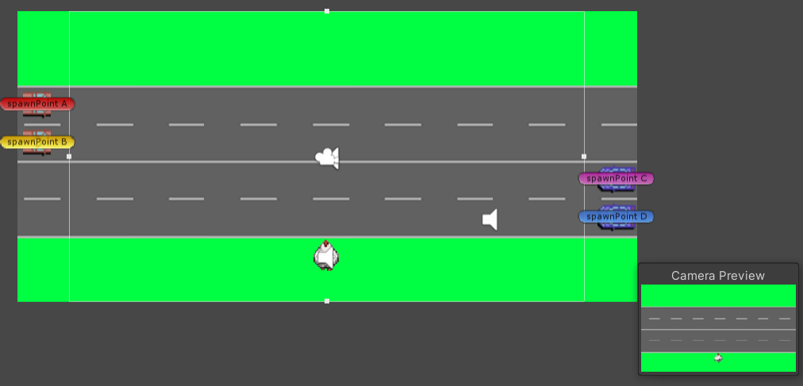

### 10.2.2 Maps

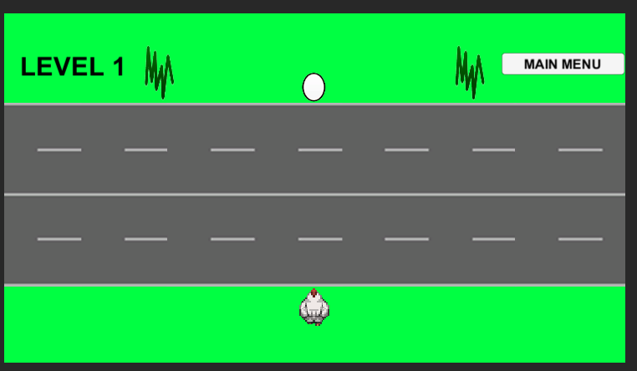……..

….

…

……

…..

….

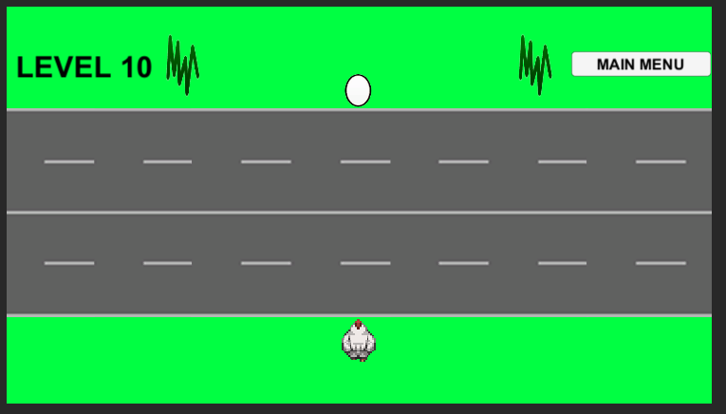

Tutorial Map

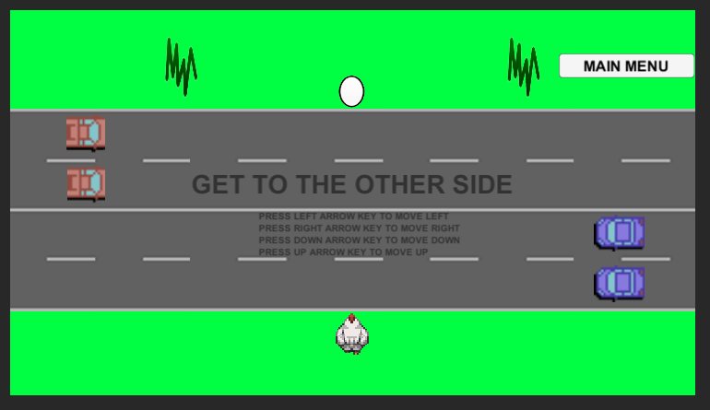

# 11 Players

## 11.1 Characters

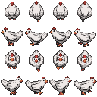

User – Chicken

## 11.2 States

Animation Chicken Up State – When up arrow is held

Animation Chicken Down State – When down arrow is held

Animation Chicken Left State – When left arrow is held

Animation Chicken Right State – When right arrow is held

Animation Idle State – Facing up

See picture above

## 13 NPC

## 13.1 Enemies



Enemy 1



Enemy 2

### 13.1.1 Enemy States

The red and blue cars will travel to in their lane at different rates of speed.

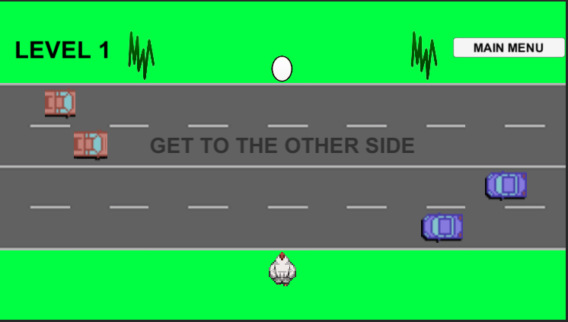

Example A

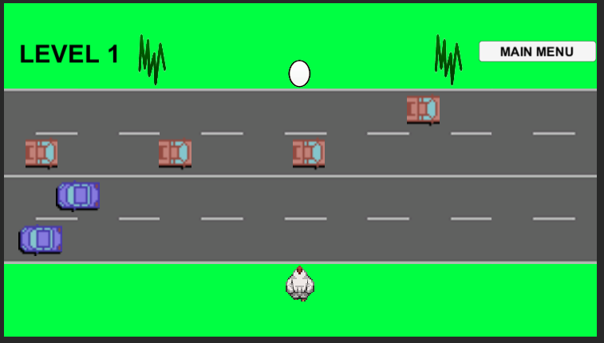

Example B

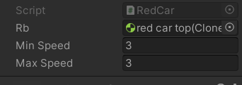

Controller for the Speed

### 13.1.2 Enemy Spawn Points

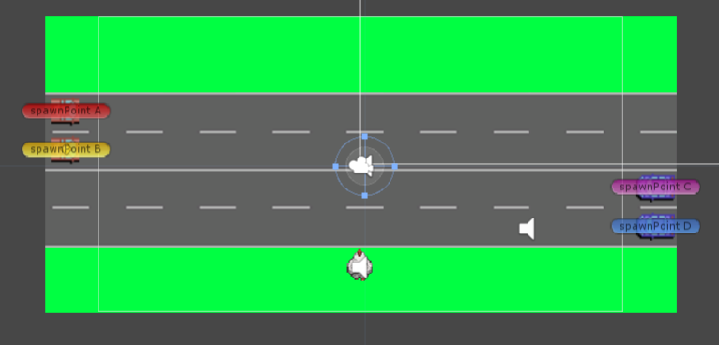

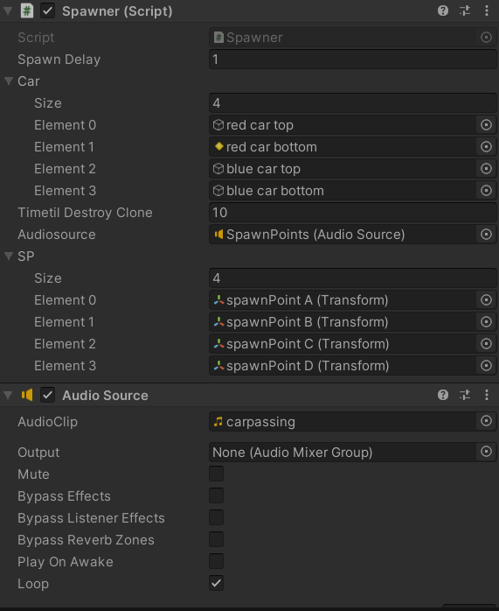

Spawn Delay until the next car spawns at points a b c or d. TimetilDestoryClone regulates how much memory is being used. It destroys cars that are off the screen. The cars passing by audio is played at each spawn to give it a realistic vibe.

# 14 Art

## 14.1 Setting

The play scenes will take place on a busy street. See pictures for references

## 14.2 Level Design

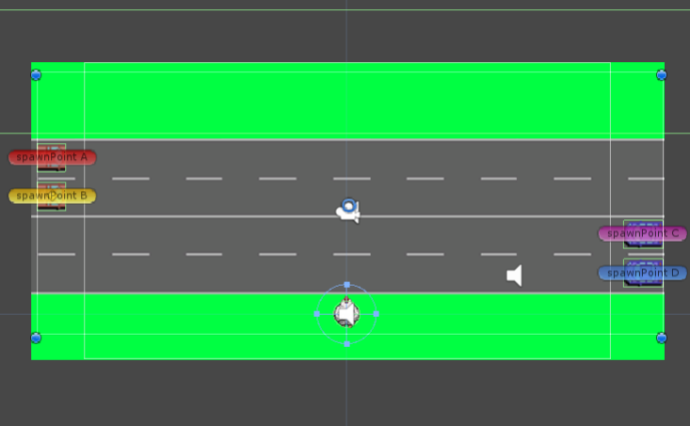

The street will be going horizontal along the x-axis

The player will travel in the x and y direction

The circle collider will determine whether the player wins or loses. If it touches the box collider(cars) then the player will lose. If it touches the box collider (other side of the road) the player will move on to the next level.

## 14.3 Audio

Win Audio - 

Lose Audio – 

Car Passing Audio - 

Main Menu Soundtrack - 

# Biography

## 15.1 Original

Death.wav

Egg.png

Grass.png

Logo.png

Logo2.png

Untitled-1.png

UI.png

## 15.2 Borrowed

Carmen Tham. (2012, November 27). *chicken dance song*. YouTube. <https://www.youtube.com/watch?v=Nt81gzIAt18>

*C64 Style Racing Game*. (2019, July 30). OpenGameArt.Org. https://opengameart.org/content/c64-style-racing-game

*LPC style farm animals*. (2012, August 15). OpenGameArt.Org. https://opengameart.org/content/lpc-style-farm-animals